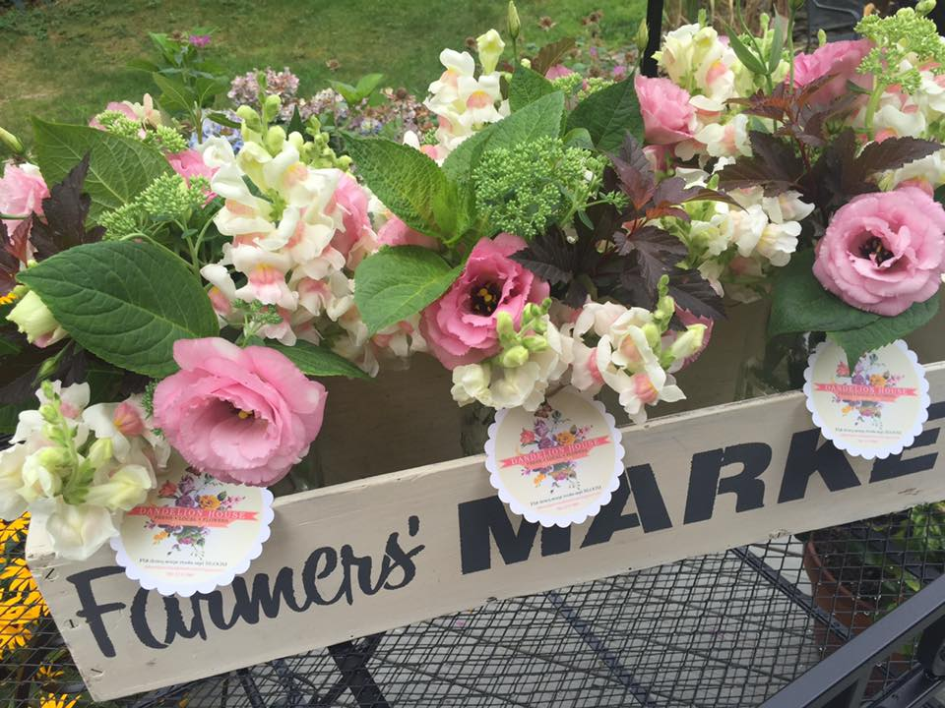

Dandelion House Cutting Garden Planting List 2018
Annuals:
Sweet peas: Johnny’s Selected Seeds www.Johnnysseeds.com
Spender Ripple Formula Mix, Mammoth Choice Mix
Farmer Baily Plugs: www.farmerbaileyplugs.com
Snapdragons (cool orange), Lisianthus, (voyage, arena croma) Nigella (delft blue), Hummingbird Poppies,
COSMOS: www.swallowtailgardenseeds.com
Bright Lights, Daydream, Dazzler, Ladybird Mix, Gloria, Tango, Sea Shell, Psyche White, Picotee, Salsiando, Velouette, Versailles Red, Versailles Flush, Xanthos.
Dahlias: www.edenbrothers.com
Bridal Bouquet Dinnerplate mix, Café Au Lait, American Sun, Rip City, Fairway Spur, Otto’s Thrill, Thomas Edison, El Sol Giant, Irish Pinwheel, Karma Chocolate, October Sky, Arabian Night

